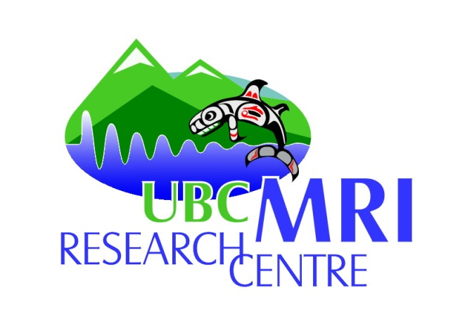

UBC MRI Research Groups

12th Annual Retreat

Rudy North Theatre, DM CBH

PROGRAM

Monday, May 7, 2018

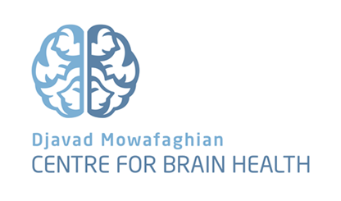

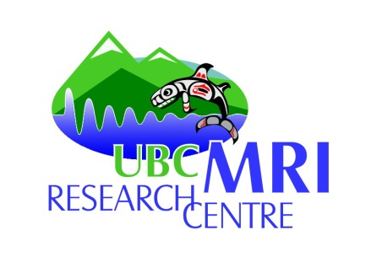
UBC MRI Research Centre

Research Groups Retreat
Rudy North Theatre
May 7th, 2018

8:30 – 8:55 BREAKFAST

9:00 - 9:05 Welcome and opening remarks Alex MacKay

9:05 - 9:45 Quantitative fMRI Bruce Pike, U Calgary
9:45 - 10:05 Tools for Diffusion MRI Andrew Yung

10:05 – 10:30 COFFEE BREAK

10:30 - 10:50 DBSI – Quantifying tissue microstructure with advanced diffusion MRI Anika Wurl

10:50 - 11:10 Effect of Chemical fixation on MWF values Piotr Kozlowski

11:10 - 11:30 Progress and pitfalls: the year in upright MR at UBC David Wilson

11:30 - 11:50 MP2RAGE with optimized multi-channel data handling Jing Zhang, Qing-San Xiang

12:00 – 1:00 LUNCH

1:00 - 1:15 Functional MR Spectroscopy in the Human Brain at 3T Erin MacMillan

1:15 - 1:40 Magnetic Tissue Properties Alex Rauscher

1:40 - 1:50 We need a 7T MR at UBC Erin MacMillan, Alex Rauscher

1:50 - 2:10 Effects of Galvanic Vestibular Stimulation on brain activity and Laura Kim, Soojin Lee
connectivity patterns

2:10 - 2:30 Power Pitch’s for Poster Session Multiple

2:30 – 3:00 POSTER SESSION (Coffee provided)

3:00 - 3:20 Machine Learning Applied to Brain MRIs for Clinical Prediction Roger Tam

3:20 - 3:40 PET/MR - a New Technology for UBC Vesna Sossi

3:40 - 3:50 7T report and brief discussion Piotr Kozlowski

3:50 - 4:00 3T report and discussion Alex MacKay

4:00 – 5:00 COCKTAIL RECEPTION

